# ***Project Documentation and Demonstration***

**Project Proposal:** Enhancing Rainfall Prediction for Sustainable Agriculture and Water Resource Management

**Project_Initialization_and_Planning_phase**

**1. Introduction**

Accurate rainfall prediction is pivotal for effective agricultural planning and water resource management, especially in regions like Maharashtra, India, where monsoon variability significantly impacts crop yields and water availability. Leveraging machine learning (ML) techniques offers a promising avenue to improve the precision of rainfall forecasts, thereby aiding farmers and policymakers in making informed decisions.

**2. Objectives**

* Develop a machine learning-based model to predict daily rainfall with high accuracy.
* Integrate the model into a user-friendly platform for stakeholders in agriculture and water management.
* Evaluate the model's performance using standard metrics to ensure reliability and robustness.

**3. Methodology**

**3.1 Data Collection and Preprocessing**

* Data Sources: Historical weather data, including parameters like temperature, humidity, wind speed, and past rainfall records, will be collected from reputable meteorological departments.
* Preprocessing Steps:
  + Handling missing values through imputation techniques.
  + Normalizing data to ensure uniformity.
  + Encoding categorical variables if present.

**3.2 Model Development**

* Algorithm Selection: Based on preliminary analyses, algorithms such as Random Forest, Gradient Boosting, and Long Short-Term Memory (LSTM) networks will be considered due to their proven efficacy in time-series forecasting.
* Training and Validation:
  + The dataset will be split into training and testing subsets.
  + Cross-validation techniques will be employed to prevent overfitting.
  + Hyperparameter tuning will be conducted to optimize model performance.

**3.3 Performance Evaluation**

* Metrics:
  + Mean Absolute Error (MAE)
  + Root Mean Square Error (RMSE)
  + R-squared (R²) score
* These metrics will provide insights into the model's accuracy and reliability.

**4. Implementation Plan**

**Phase 1: Data Acquisition and Cleaning**

* Gather historical weather data.
* Perform data cleaning and preprocessing.

**Phase 2: Model Development**

* Train multiple ML models.
* Evaluate and select the best-performing model.

**Phase 3: Integration and Deployment**

* Develop a user interface for stakeholders.
* Integrate the model into the platform.
* Deploy the system for pilot testing.

**Phase 4: Feedback and Iteration**

* Collect feedback from users.
* Refine the model and interface based on insights.

**5. Expected Outcomes**

* A robust ML model capable of accurately predicting daily rainfall.
* A user-friendly platform accessible to farmers and water resource managers.
* Enhanced decision-making capabilities leading to optimized agricultural practices and water usage.

**6. Future Enhancements**

* Incorporate Real-time Data: Integrate live weather data feeds to provide up-to-date forecasts.
* Expand Geographical Scope: Adapt the model for use in other regions with similar climatic conditions.
* Integrate with IoT Devices: Utilize sensors for real-time soil moisture and atmospheric data to further refine predictions.

By implementing this project, we aim to empower stakeholders in agriculture and water management with precise rainfall forecasts, facilitating proactive and informed decision-making that promotes sustainability and resilience against climatic uncertainties.

**2)Data Collection and Preprocessing Phase**

**Data Collection :**

**We have used the following data for the model to train on :**

[**https://docs.google.com/spreadsheets/d/1RA2OO0LZTeQykI_mvnensAjp6LM4YzWI1Tz0SUG5-Ao/edit?gid=121883362#gid=121883362**](https://docs.google.com/spreadsheets/d/1RA2OO0LZTeQykI_mvnensAjp6LM4YzWI1Tz0SUG5-Ao/edit?gid=121883362#gid=121883362)

**Data Quality Report :**

**Analyzing the data:**

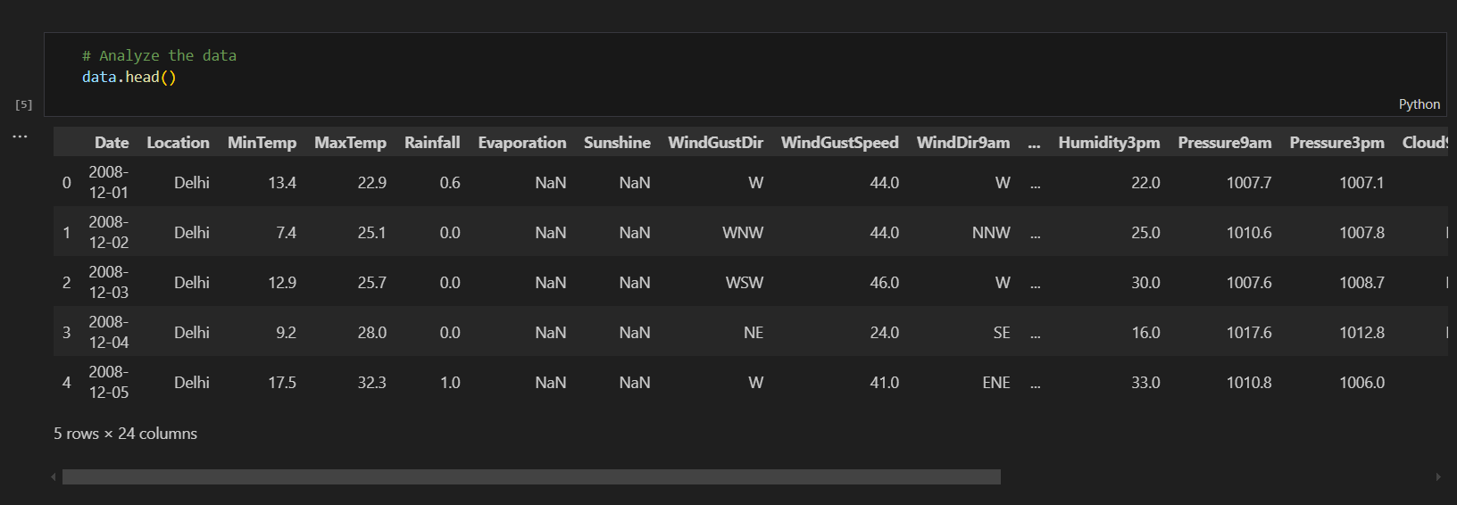

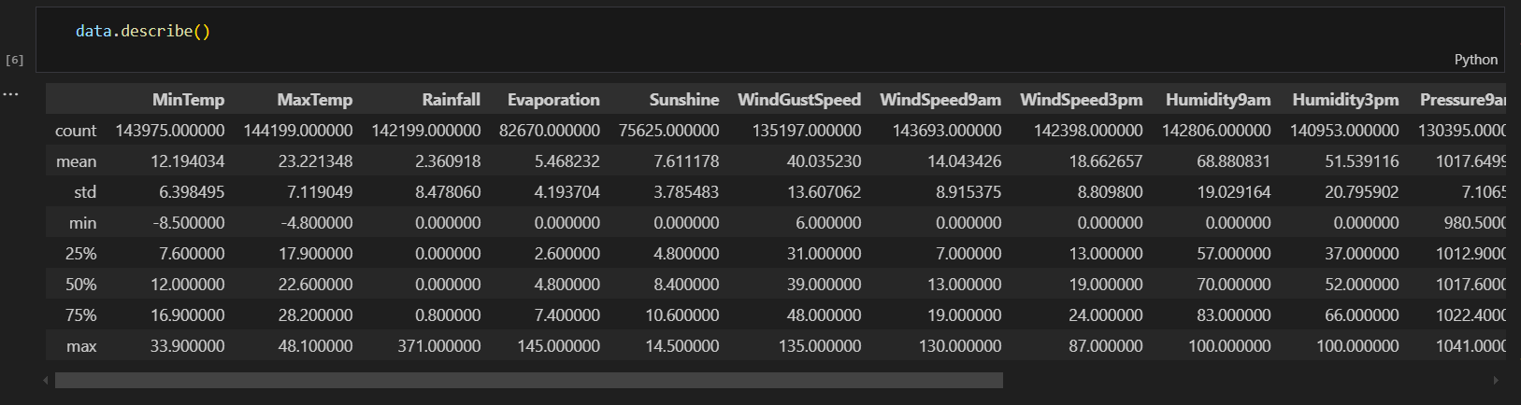

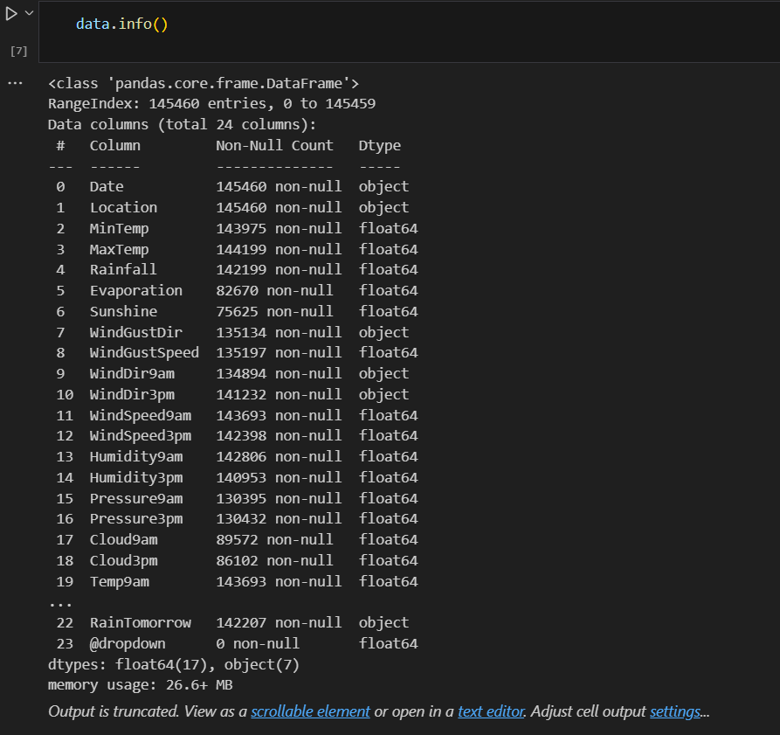

**Preprocessing Report : ( Visualisation Report )**

**1.The HeatMap of the data**

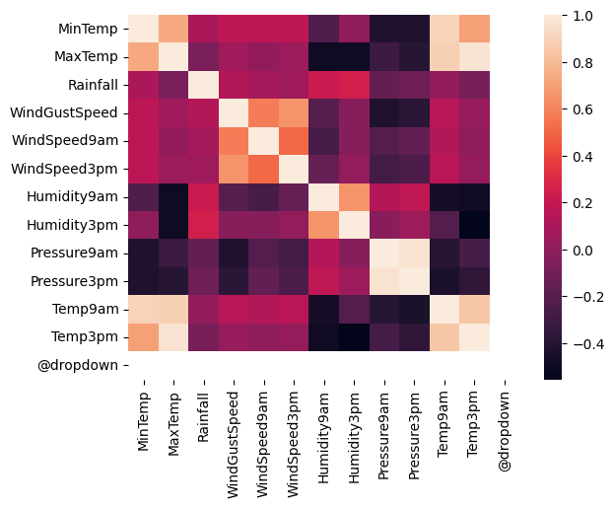

1. **The Boxplot**

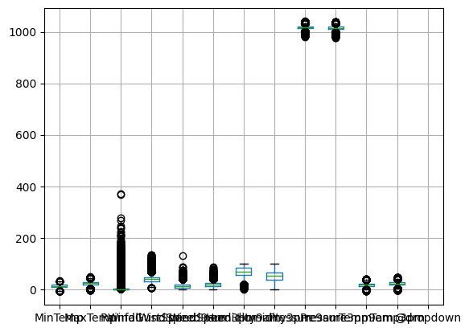

1. **The Jointplot - 1**

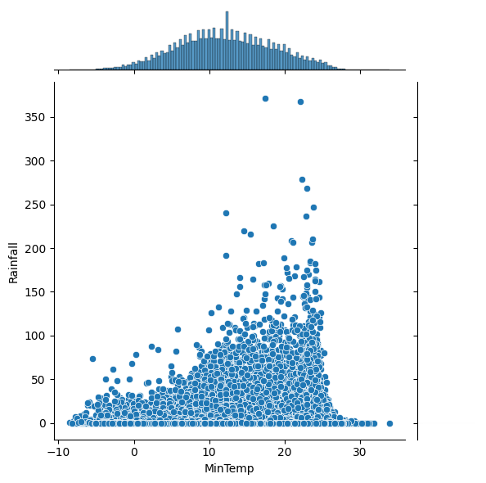

1. **The Jointplot - 2**

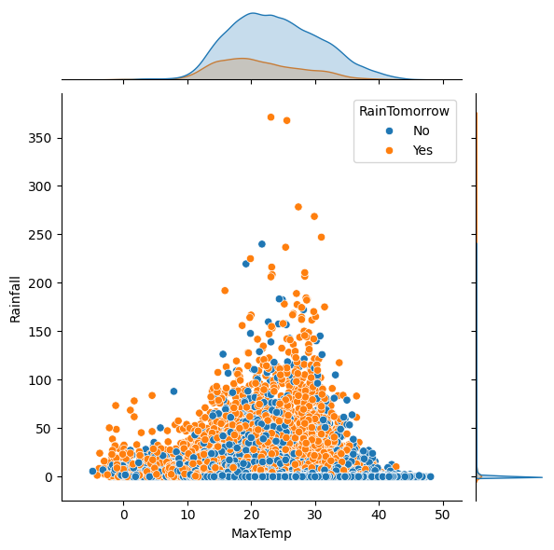

1. **The Histogram**

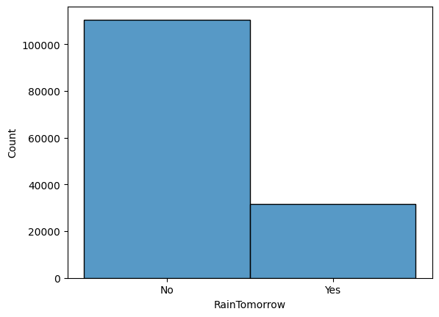

1. **The Scatter Plot**

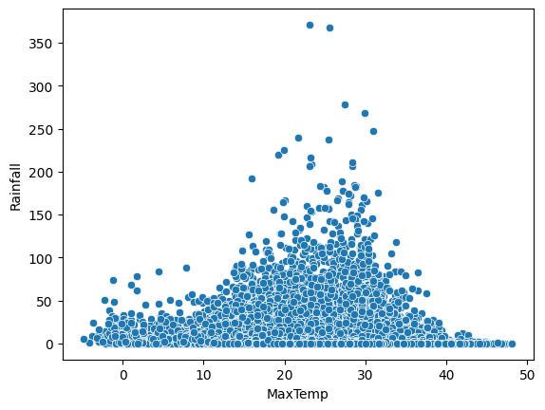

1. **The Distribution Plot**

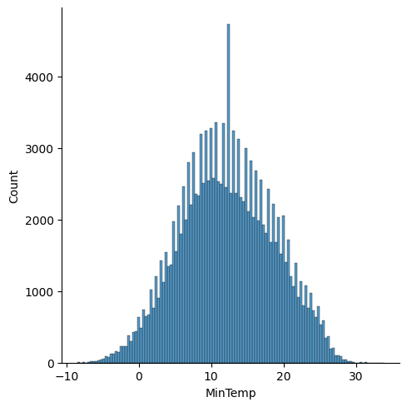

**Splitting the data:**

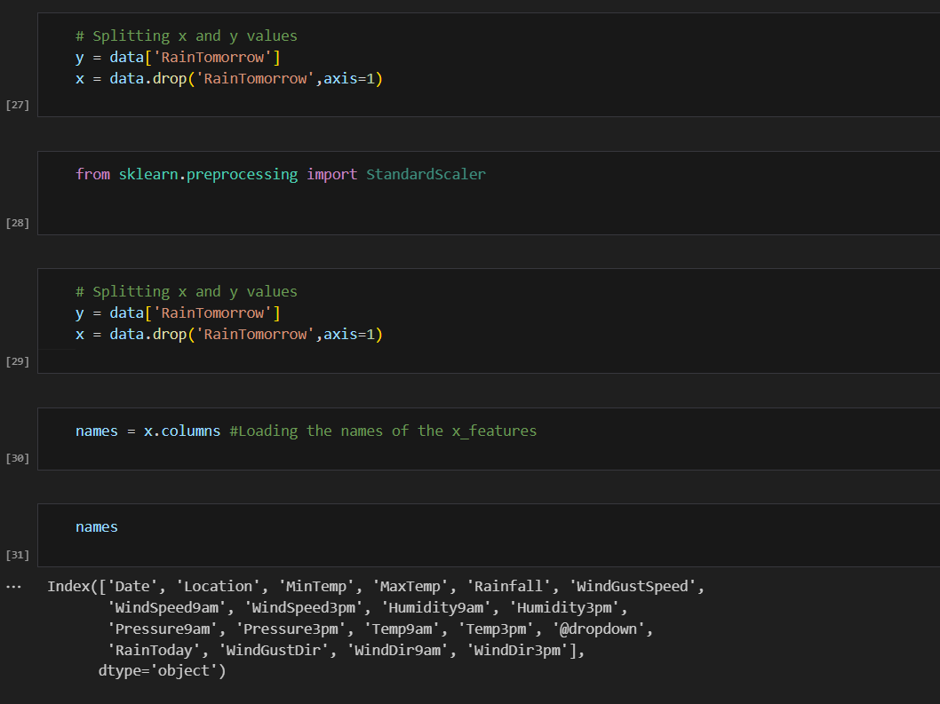

**# Splitting the data into train and test**

**x_train,x_test,y_train,y_test = model_selection.train_test_split(x,y,test_size=0.2, random_state=0)**

**3)Model Development Phase**

**Initial Training Code :**

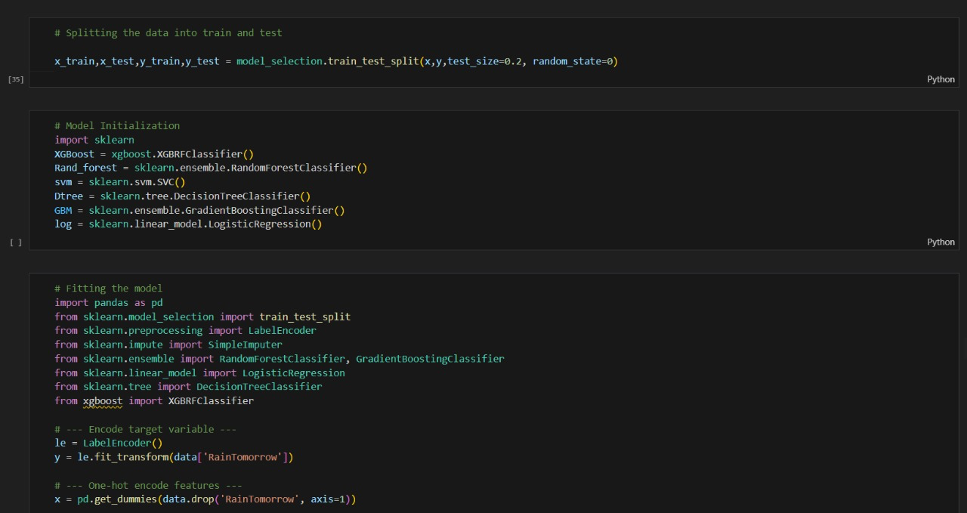

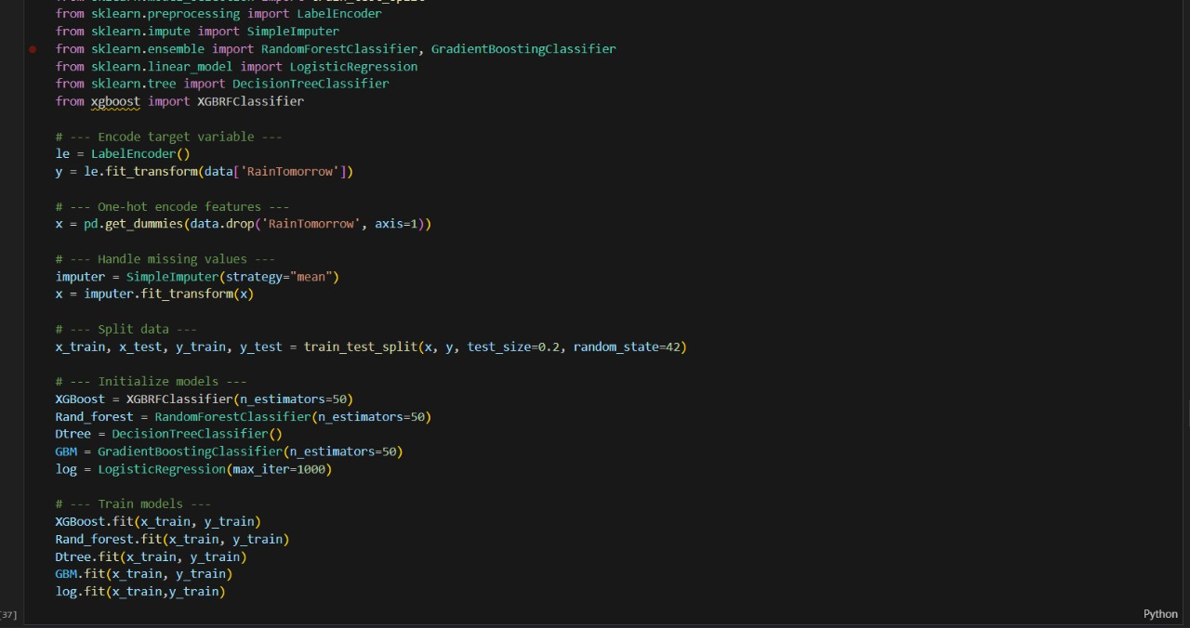

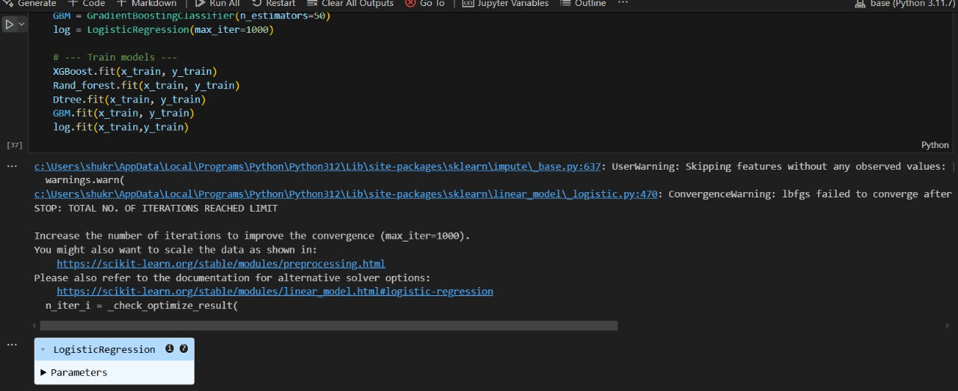

**Model Evaluation and Validation Report :**

* **Accuracy Score**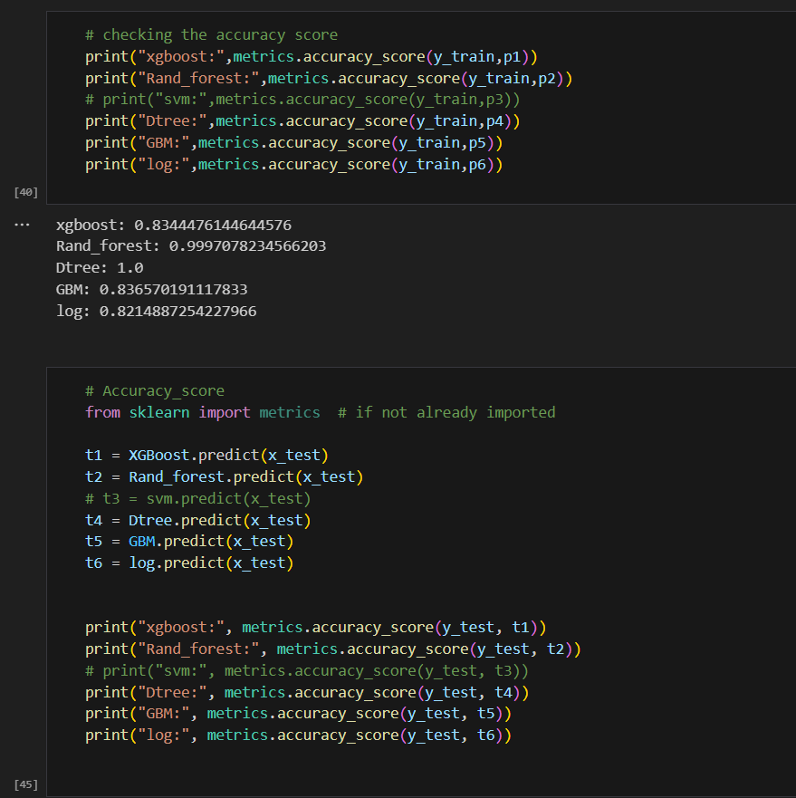

**xgboost: 0.8252096796370136**

**Rand_forest: 0.8323594115220679**

**Dtree: 0.7958545304551079**

**GBM: 0.8327031486319263**

**log: 0.8202254915440671**

**Confusion Matrix**

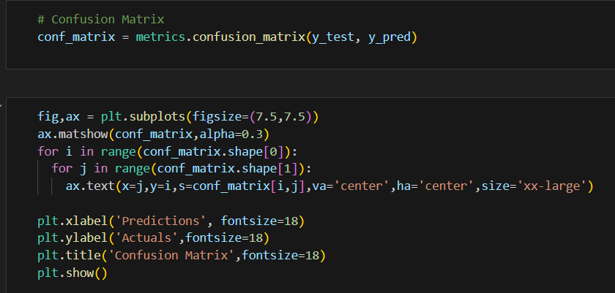

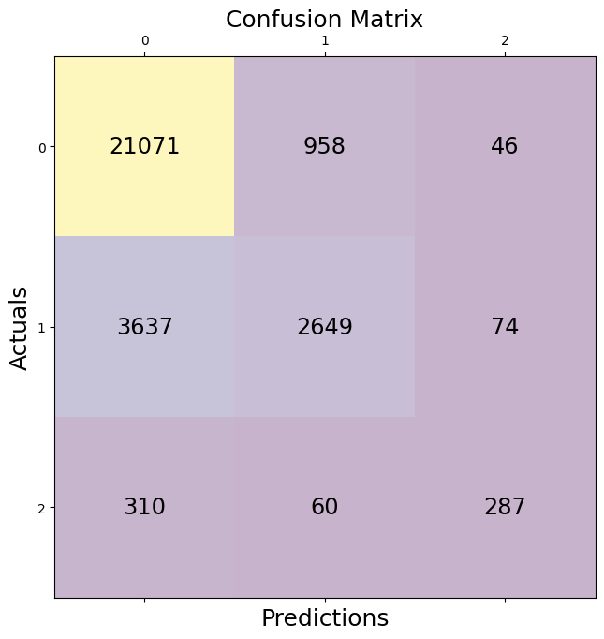

**Save The Model:**

* **Model is saved using pickle**

